**Ansible Case Study**

1. Create 3 similar VM’s and configure 1 VM as Ansible Master and the other 2 for Apache and NGINX Slave respectively.

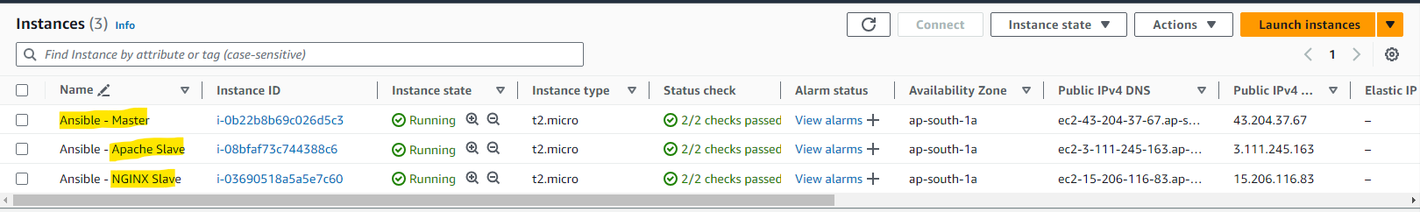

1. Once configured, create 3 Roles by using ‘sudo ansible-galaxy init <role_name>’ :
   1. Apache Role : To install, configure index.html and check service.
   2. NGINX Role : To install, configure index.html and check service.
   3. Java Role : To install java once Apache / NGINX is installed on either of the Machines.

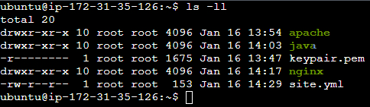

1. Create the tasks you want to run under role_name/tasks/main.yml :
   1. Apache :

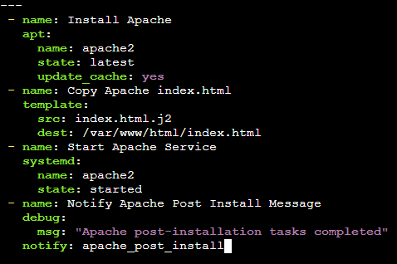

* 1. NGINX :

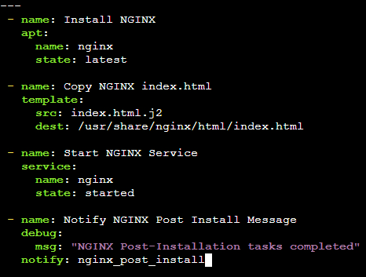

* 1. Java :

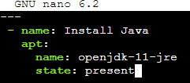

1. Once the main.yml is configured, configure the handlers of NGINX and Apache Role :
   1. Apache

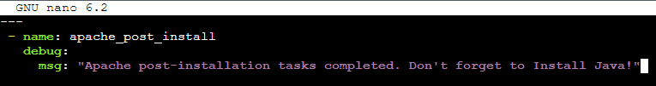

* 1. NGINX

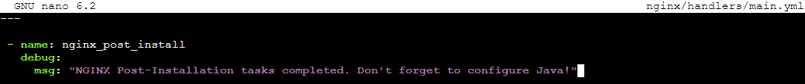

1. Configure the template folder to have the contents of index.html file on each of the machines :
   1. Apache :

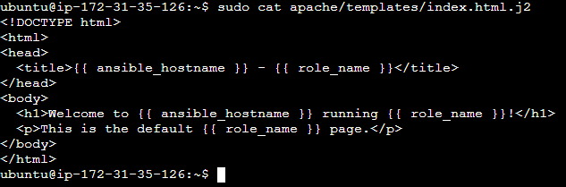

* 1. NGINX :

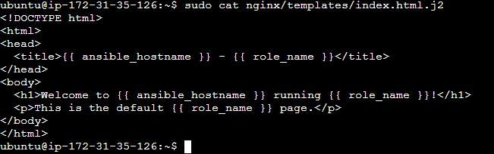

1. Once all is configured, run the site.yml file to execute all the roles created by using ‘sudo ansible-playbook site.yml’

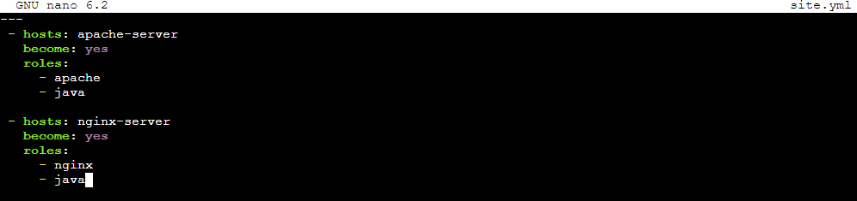

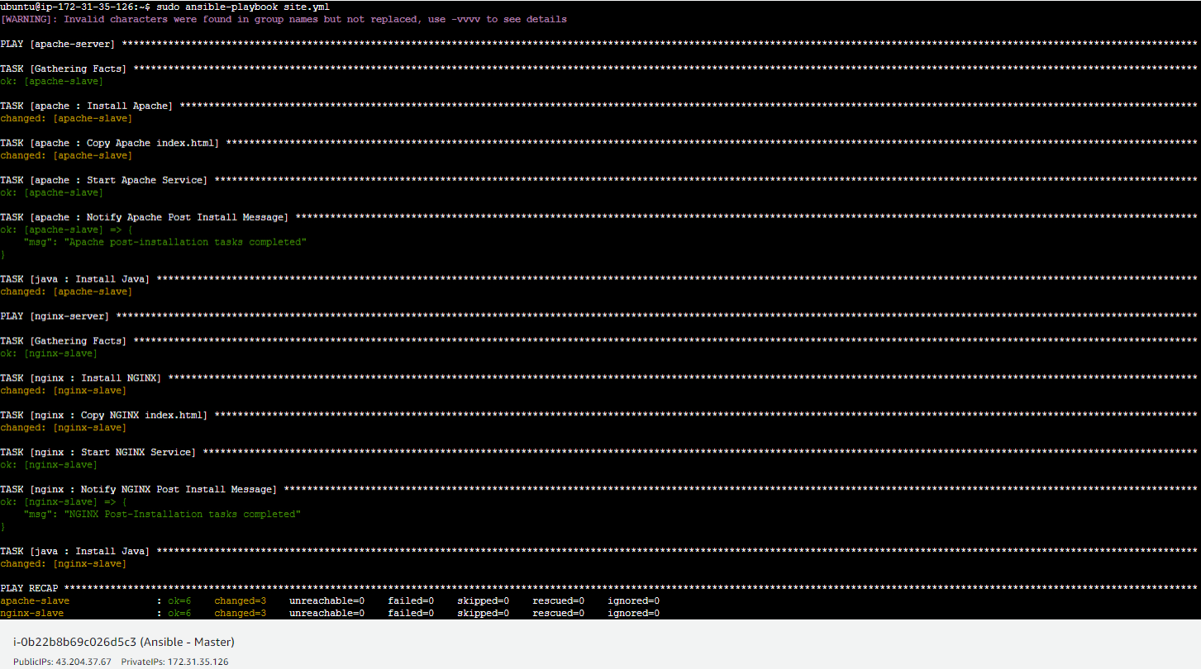

1. As executed, all the files have been successfully installed. To check further, connect to both the Machine via <http://public_ip>
   1. Apache



* 1. NGINX

